150182-kipruto Isaac

Lab - Social Engineering with ZPhisher **Disclaimer**

This lab is for informational and educational purposes only. I believe that ethical hacking and cyber security should be familiar subjects to anyone using digital information and computers. To beat the hacker, you must be the hacker!

**Overview**

Social engineering is the art of manipulating people to gain crucial information that can be utilized for performing malicious actions. Instead of targeting the weakness of a network or a machine in social engineering, we target people’s weaknesses.

ZPhisher is an advanced phishing toolkit that is an upgraded version of Shellphish. ZPhisher’s main source code comes from Shellphish, but ZPhisher comes with upgrades and has removed some of the unnecessary code from Shellphish. HTR-Tech develops ZPhisher. ZPhisher can run from Kali Linux and an Android device using Termux.

**Installing ZPhisher**

From your kali desktop, launch a new terminal.

ZPhisher start page.

When the victim attempts to log in to their Instagram account, their credentials are captured and sent back to the attack machine.

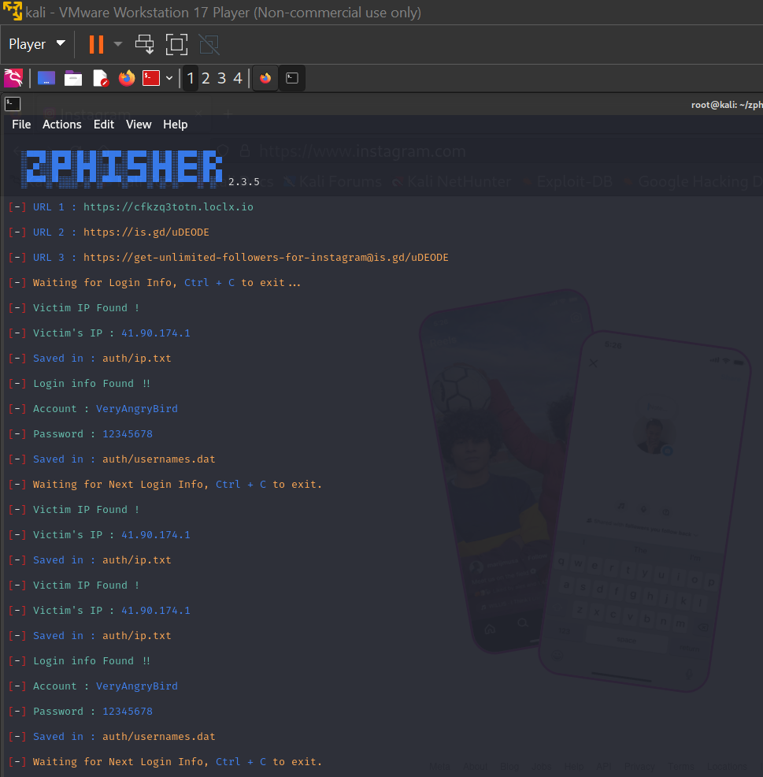

When the victim attempts to log in to their Instagram account, their credentials are captured and sent back to the attack machine.



To see the saved results for the captured credentials, at the prompt type:

